**Docker Container Restart Policies**

It's often a good idea to run containers with a restart policy. This is a basic form of self-healing that allows the local Docker engine to automatically restart failed containers.

Restart policies are applied per container. They can be configured imperatively on the command line as part of docker run commands or declaratively in YAML files for use with higher-level tools such as Docker Swarm, Docker Compose, and Kubernetes.

**In this document, we will get to know about the following restart policies:**

* **always**
* **unless-stopped**
* **on-failure**

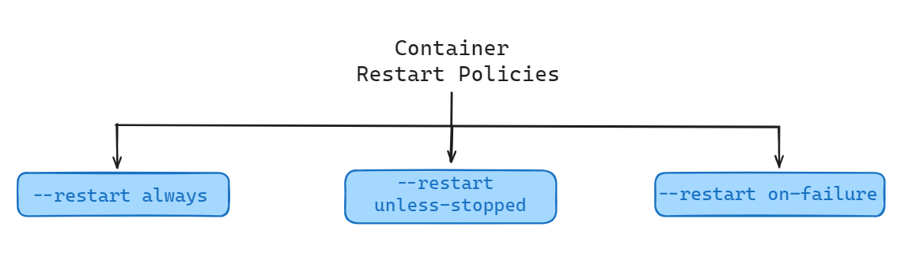

**Restart Policies Explained**

**always:**

The always policy is the simplest. When a container has this restart policy, Docker will automatically restart the container if it stops or encounters an error.

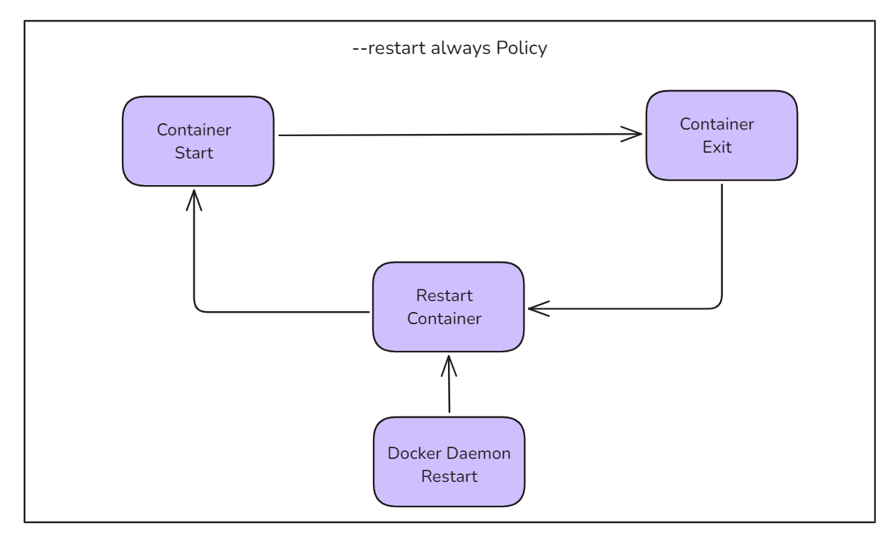

**Demonstration**

Start a new interactive container with the --restart always policy and run a shell process:

docker run --name neversaydie -it --restart always alpine sh

When we started the alpine container, we told it to run the shell(sh). This makes the shell the one-and-only process running inside the container. We can see this by running ps -elf from inside the container. We will see a output similar to this:

PID USER TIME COMMAND

1 root 0:00 sh

7 root 0:00 ps -elf

The first process in the list, with PID 1, is the shell we told the container to run. The second process is the ps -elf command we ran to produce the list. This is a short-lived process that exits as soon as the output is displayed.

Type exit from the shell to kill the container's PID 1 process and stop the container. Docker will automatically restart it because it has the --restart always policy.

**Check the container’s status:**

docker ps

**We should see that the container is running again.**

CONTAINER ID IMAGE COMMAND CREATED STATUS PORTS NAMES

9a9fa81a0691 alpine "sh" 14 minutes ago Up 5 seconds neversaydie

The container was created 14 minutes ago but has only been up for 5 seconds. This is because the exit command killed it, and Docker restarted it.

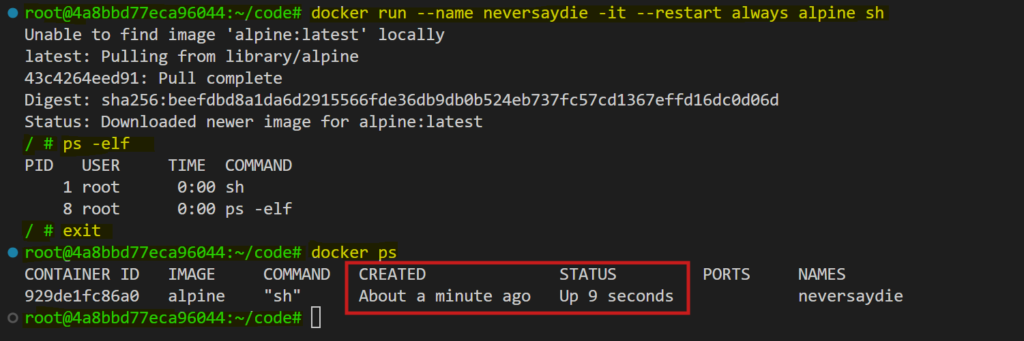**You will see a output similar to this:**

Be aware that Docker has restarted the same container and not created a new one. If we inspect it with docker inspect, we can see the restartCount has been incremented.

**docker inspect neversaydie --format '{{.RestartCount}}'**



An interesting feature of the --restart always policy is that if we stop a container with docker stop and then restart the Docker daemon, the container will be restarted.

To illustrate:

1. Start a new container with the --restart always policy and intentionally stop it with the docker stop command.
2. The container will be in the Stopped (Exited) state.
3. Restart the Docker daemon, and the container will be automatically restarted when the daemon comes back up.

**unless-stopped**

The main difference between the always and unless-stopped policies is that containers with the --restart unless-stopped policy will not be restarted when the daemon restarts if they were in the Stopped (Exited) state.

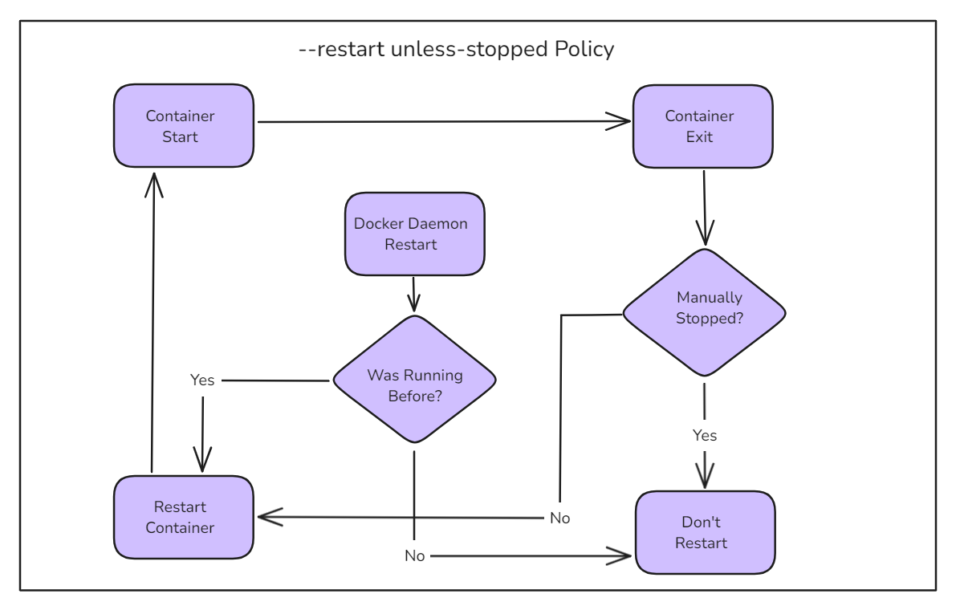

**Example**

**Create two new containers:**

docker run -d --name always --restart always alpine sleep 1d

docker run -d --name unless-stopped --restart unless-stopped alpine sleep 1d

**Verify both containers are running:**

docker ps

**we will see output similar like this:**

CONTAINER ID IMAGE COMMAND CREATED STATUS PORTS NAMES

b69a8c552269 alpine "sleep 1d" 47 seconds ago Up 46 seconds unless-stopped

f1b6f3e6a555 alpine "sleep 1d" 47 seconds ago Up 46 seconds always

**Stop both containers:**

docker stop always unless-stopped

**Verify both containers are stopped:**

docker ps -a

**we will see output similar like this:**

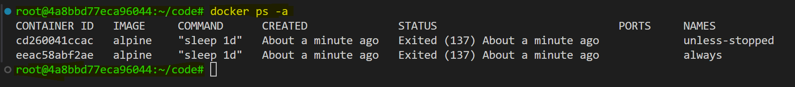

**Restart Docker:**

systemctl restart docker

**Check the status of the containers:**

docker ps -a

**we will see output similar like this:**

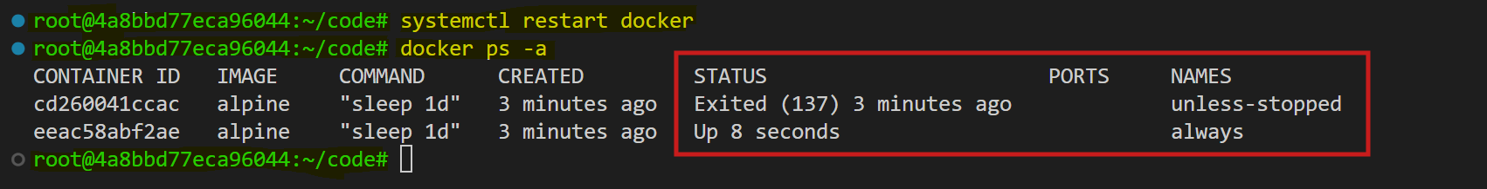

The always container has been restarted, but the unless-stopped container has not.

**on-failure:**

The on-failure policy will restart a container if it exits with a non-zero exit code. It will also restart containers when the Docker daemon restarts, even those that were in the stopped state.

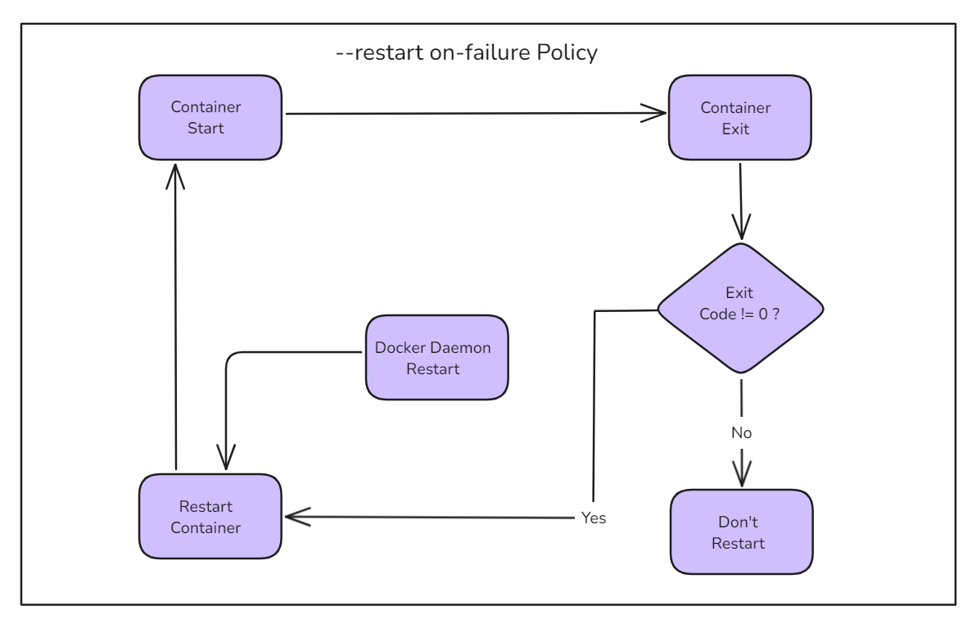

**Demonstration:**

**Use the docker run command with the --restart option set to on-failure.**

docker run -d --name on-failure --restart on-failure alpine sleep 1d

**Verify the restart policy:**

docker inspect on-failure --format '{{.HostConfig.RestartPolicy}}'

